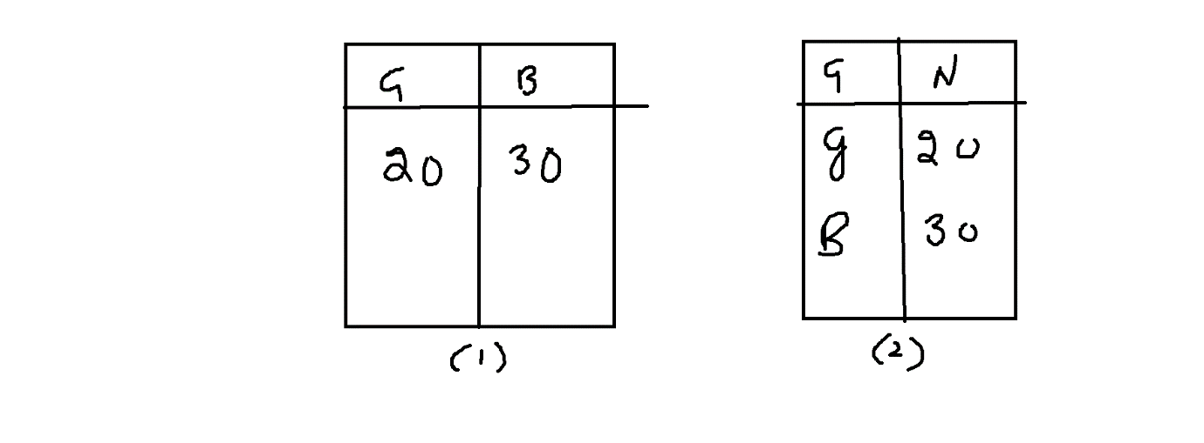

|  |
| --- |
|  |
|  |
|  |
|  |
|  |
|  |
|  |
|  |

|  |  |
| --- | --- |
|  |  |
|  |  |
|  |  |

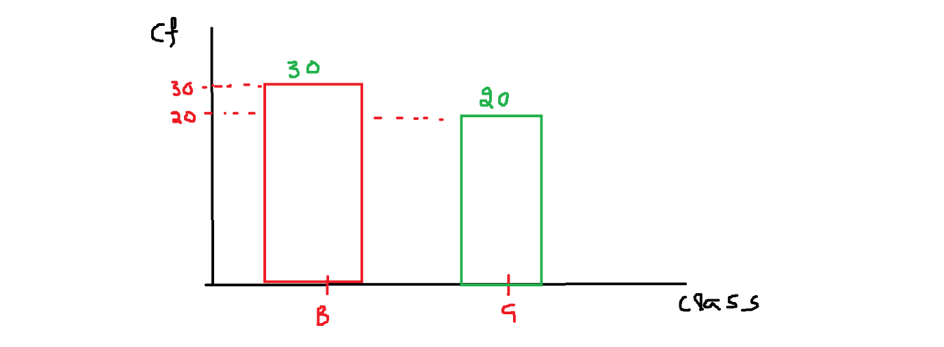

|  |  |  |
| --- | --- | --- |
|  |  |  |
|  |  |  |
|  |  |  |
|  |  |  |

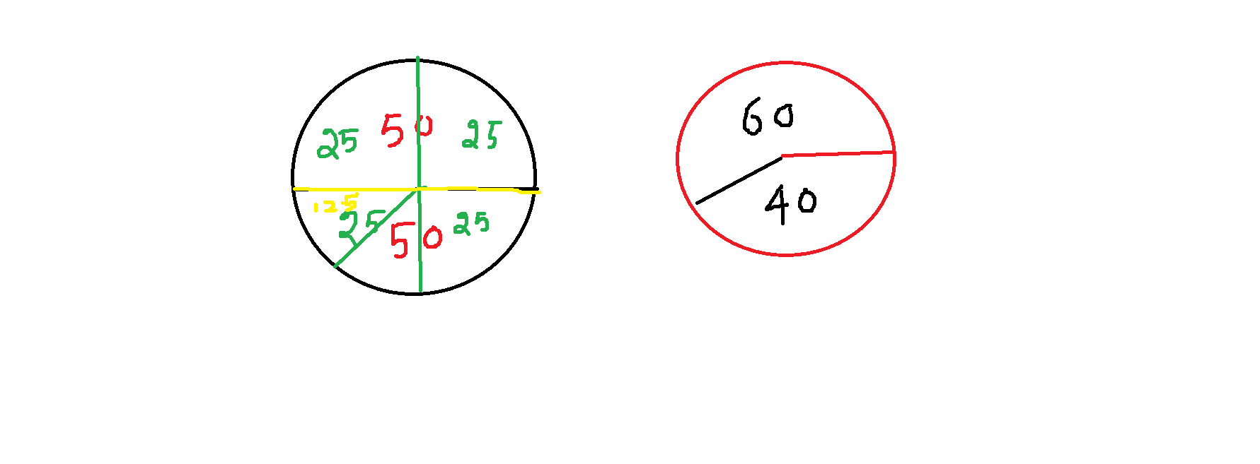

|  |  |
| --- | --- |
| Class Interval | Interval frequency |
| 0-5 | 1 |
| 5-10 | 2 |
| 10-15 | 1 |
| 15-20 | 3 |
| 20-25 | 3 |

$$Whenever you see the raw data :$$

$$There is a numerical column having the number$$

$$Graphical Represenatation:$$

$$Histogram:$$

$It is Graphical represntation of frequncy distribution table$

$any graph we need x-axis and y-axis$

$x-axis: class interval$

$y-axis:interval frequency$

$x-axis: numerical column$

$y-axis:numerical column$

$histogram : numerical vs numerical$

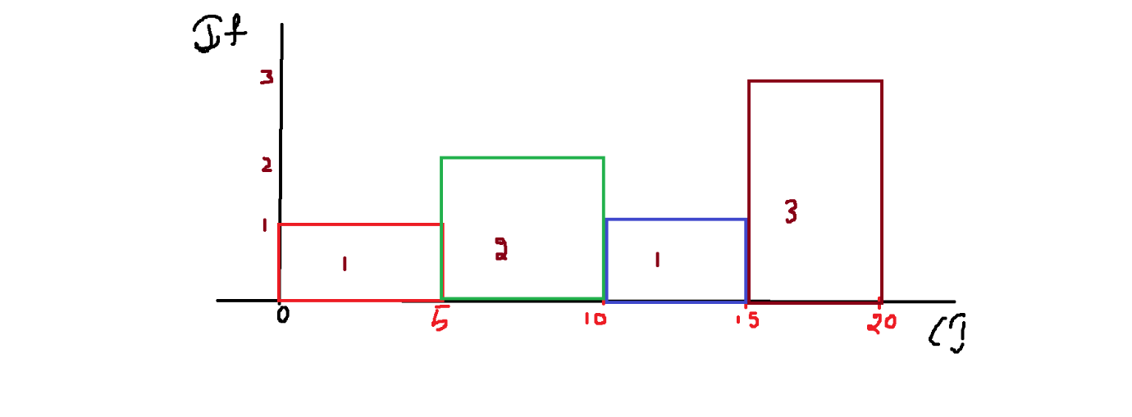

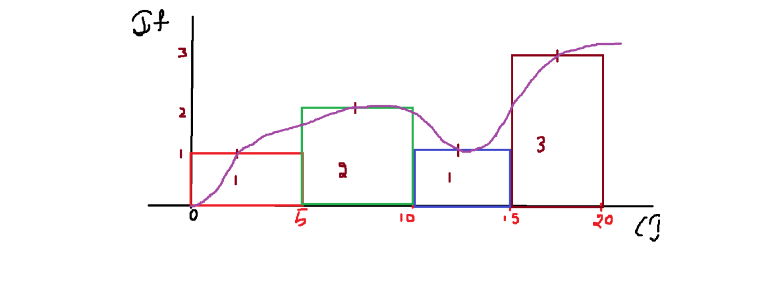

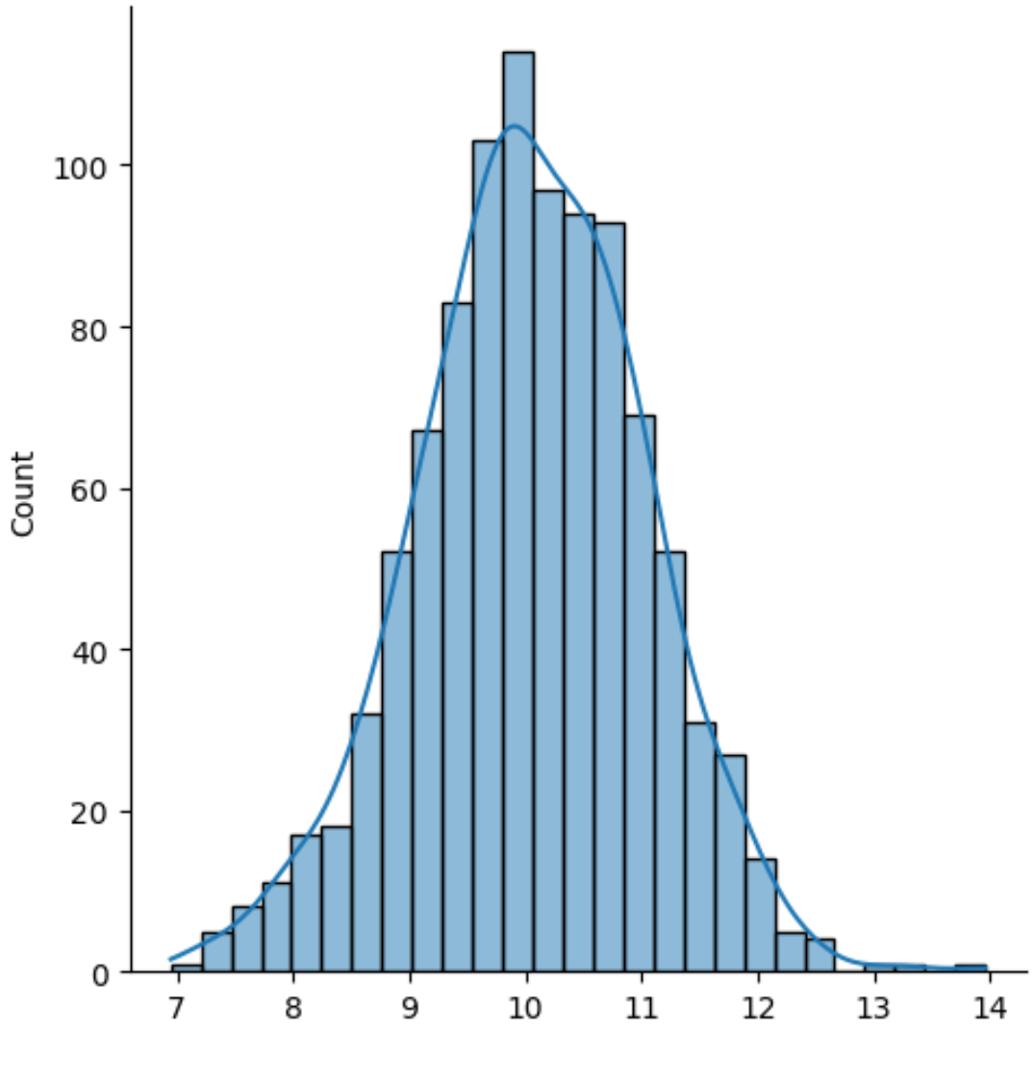

$Rule:$

$$We have raw data====CI and IF==Frequncy distribution table===Histogram====== >Distribution plot$$